

Milby Primary School
SEND Policy
2024 - 2025

Definitions

SEND – Special Educational Needs and Disabilities
SENDCo – Special Educational Needs and Disabilities Coordinator
EHCP – Education, Health and Care Plan
SLT – Senior Leadership Team
DfE – Department for Education
QTS – Qualified Teacher Status
LEA – Local Education Authority
CoP – Code of Practice

Compliance

This policy complies with the statutory requirement laid out in the SEND Code of Practice 0 to 25 years January 2015 and has been written with reference to the following guidance and documents:

- Equality Act 2010: advice for schools – DfE February 2013
- SEND Code of Practice 0 – 25 (September 2014, updated January 2015)
- Schools SEN Information Report Regulations (2014)
- Statutory Guidance on Supporting pupils with medical conditions at school April 2014
- The National Curriculum in England Key Stage 1 and 2 framework document Sept 2013
- Teachers Standards 2012
- Safeguarding Policy
- Inclusion Policy
- Anti-Bullying Policy

Beliefs and Values
At Milby Primary School we recognise that our pupils have a wide variety of needs and aspirations. We are fully committed to the inclusion of all pupils in a broad and balanced curriculum, made accessible to all through adaptations to lessons, outcomes and activities, as well as providing additional support as and when this is needed.

The needs of a minority of the children require consideration beyond that given to other pupils (a Special Educational Need). Government Legislation dictates the framework within which the school operates (the Special Educational Needs Code of Practice 2014, and the Children’s and Families Act 2014), and further guidance is provided by both the Government and Local Authority. All staff are required to follow this guidance, supported by the SENDCo. All teachers are responsible and accountable for the progress and development of all of the children in their class, including those with SEND. We recognise that high quality teaching, with adaptations made for individual pupils, is the first step in responding to pupils who have or may have SEND.

As well as their academic needs, we recognise the need to support the social, emotional and mental health needs of all of our pupils. Whilst behaviour is not classified as SEN, we understand the impact of a child’s mental health on their behaviour, self-esteem and ability to learn effectively. We consider all possible barriers to learning to ensure the right provision is put in place, for every individual child who may need it. All pupils’ behaviour is responded to in line with our Behaviour Policy, however reasonable adjustments can be made to accommodate individual needs.

The SENDCo and SEN Governor
At Milby Primary School, the SENDCo is Mrs Witts. Mrs Witts is a qualified teacher, which is a requirement set out by The Education (Special Educational Needs Co-ordinators) (England) Regulations 2008. Since 1 September 2009, schools have been required to ensure that, in addition to QTS, new SENDCos hold the National Award for Special Educational Needs (SEN) Co-ordination, or gain it within three years of taking up the post. Mrs Witts completed this award in 2018 and is also a member of the SLT. The governor with responsibility for SEND is Mrs Anthea Lawton. This policy has been written by the SENDCo in liaison with the SEND Governor and the SLT.

The role of the SEND Co-ordinator
The SENDCo plays a crucial role in the school’s SEN provision. This involves working with the head teacher and Governing Body to determine the strategic development of the policy. Other responsibilities include:

- Overseeing the day-to-day operation of the policy
- Co-ordinating the provision for pupils with SEND
- Advising on the graduated approach to providing SEN support
- Liaising with and giving advice to fellow teachers
- Advising on the deployment of resources, including the learning support assistants and teaching assistants, to meet pupils’ needs effectively
- Managing learning support assistants
- Overseeing pupils’ records and ensuring that record keeping for all pupils with SEND are kept up to date
- Liaising with the parents of pupils with SEND and parents who have concerns
- Making a contribution to INSET
- Being a key point of contact with external agencies
- Liaising with feeder schools to ensure smooth transitions between schools

The school recognises the important contribution that external support services make in assisting to identify, assess, and provide for pupils with SEND. When it is considered necessary, colleagues from the following support services will be involved with pupils with SEND:

- Educational psychologists
- Medical officers
- Speech therapists
- Specialist teaching service
- Physiotherapists
- Hearing impairment services
- Visual impairment services
- Occupational health service
- Integrated disability service

In addition, important links are in place with the following organisations:

- The LEA
- Specialist Services
- Education Welfare Officer
- Social Services

Aims of this policy
- To follow the guidance and principles as set out in the SEND Code of Practice 2014.
- To ensure that all pupils have access to a broad and balanced curriculum to enable them to experience achievement, success and pride.
- To encourage achievement, high aspirations and success through planning appropriate next steps of learning for all pupils with SEND.
- To provide adaptations to the curriculum appropriate to the individual’s needs and ability.
- To ensure the identification of all pupils requiring SEN provision as early as possible in their school career.
- To ensure that SEN pupils take as full a part as possible in all school activities.
- To work in partnership with parents of SEN pupils, in order for them to be kept fully informed of their child’s progress and attainment.
- To ensure that SEN pupils are involved, where possible, in decisions affecting their future SEN provision.
- To identify which external agencies are appropriate, when a multi-professional approach is needed to meet the needs of a pupil.
- To recognise the importance of additional transition arrangements in supporting children with SEND.
- To provide support, training and advice to achieve a level of staff expertise to meet pupil need.

We recognise that many pupils will have special needs at some time during their school life. In implementing this policy, we believe pupils will be helped to overcome their difficulties. Whilst many factors contribute to the range of difficulties experienced by some children, we believe that much can be done to overcome them by parents, teachers and pupils working together.

How the aims will be achieved
Supported by the SENDCo, all staff involved in teaching and learning will:

- Have regard to the Code of Practice (2014) on the identification and assessment of special educational needs
- Follow the guidelines laid down by Warwickshire Education Authority
- Work in partnership with the child, parent and carers, all staff, governors and outside agencies
- Use a range of differentiation to provide effective learning opportunities for all pupils
- Provide targeted support that is additional to or different from that provided as part of the schools’ regular curriculum to children who have been identified as having special educational needs
- Recognise the importance of early identification so that, if the child’s difficulties prove less responsive to the provision made by the school, an early start can be made in considering the additional help the child may need
- Produce an intervention plan tailored to each individual child’s needs. Realistic targets will be set and the plans will be reviewed regularly and involve the child, parent, teacher and all support services currently involved
- Use a variety of complementary approaches to support the child – differentiation, 1-1 intervention, group intervention, whole class learning, support within the class, or withdrawal when appropriate
- Include the child within the class, wherever and whenever practicable
- Endeavour to use all resources appropriately and efficiently
- Make full use of all the support agencies that have been made available through the LEA

Admission of pupils with SEND
The Governing Body believes that the admissions criteria should not discriminate against pupils with SEND and has due regard for the practice advocated in the Code of Practice, in that ‘All schools should admit pupils already identified as having special educational needs, as well as identifying and providing for pupils not previously identified as having SEN. Pupils with special educational needs but without statements must be treated as fairly as all other applicants for admission.’ (CoP 1:33)

Identification of special needs
The definition of special education needs according to the SEND Code of Practice 2014 is:

A pupil has SEN where their learning difficult or disability calls for special educational provision, namely provision different from or additional to that normally available to pupils of the same age.

Areas of SEND can be considered as falling under four broad areas, as outlined in the SEND Code of Practice and these areas can be used to help identify a child’s primary area of need:

1. Communication and interaction
That is, children that find communicating and understanding language difficult. This may be due to a specific language difficulty or conditions such as autistic spectrum disorder (ASD), pragmatic difficulties or sensory processing disorder.

2. Cognition and learning
That is, children that have learning difficulties that mean they are not able to learn basic numeracy or literacy skills. A child or young person with a specific learning difficulty (SpLD) may have difficulty with one or more aspects of learning. This includes a range of conditions such as dyslexia (difficulties with reading and spelling); dyscalculia (maths); dyspraxia (co-ordination), dysgraphia (writing) and Global Developmental Delay. Children with severe learning difficulties may also have difficulties in acquiring basic skills in any area and this may also impede their physical development.
3. Social, emotional and mental health
That is, children that have severe difficulties in managing their emotions or behaviour. They can include anxiety, attention deficit disorder (ADD), attention deficit hyperactive disorder (ADHD) and attachment disorder. Children with ASD can also present with social, emotional and mental health difficulties.

4. Sensory and/or physical
That is, children with physical or sensory disabilities which affect their ability to access the environment or learning. This may include visual or hearing impairment, motor difficulties, cerebral palsy or congenital conditions, injury or disease.

At Milby Primary School, identification of special needs is based on internal teacher assessments along with information received from parents and external agencies, in consultation with the SENDCo. It is important to take into account that a child may have needs that cover more than one of these ‘broad’ areas or it may not be clear which area their difficulty falls under. A child or young person with one or more of the above mentioned conditions may not necessarily have SEND, but if the nature of their disability requires them to have special educational provision, they will also be covered by the definition of SEND. It is also important to highlight that a diagnosis does not automatically mean that a child will be placed on the SEND register, unless the diagnosed need causes a barrier to the child’s learning or ability to access the school curriculum or environment.

Teaching and learning – the graduated approach
Teaching pupils with SEND is a whole-school responsibility. The core of the teachers’ work involves a continuous cycle of assessing, planning, teaching, and reviewing, taking into account the differences in pupils’ abilities, aptitudes, and interests.

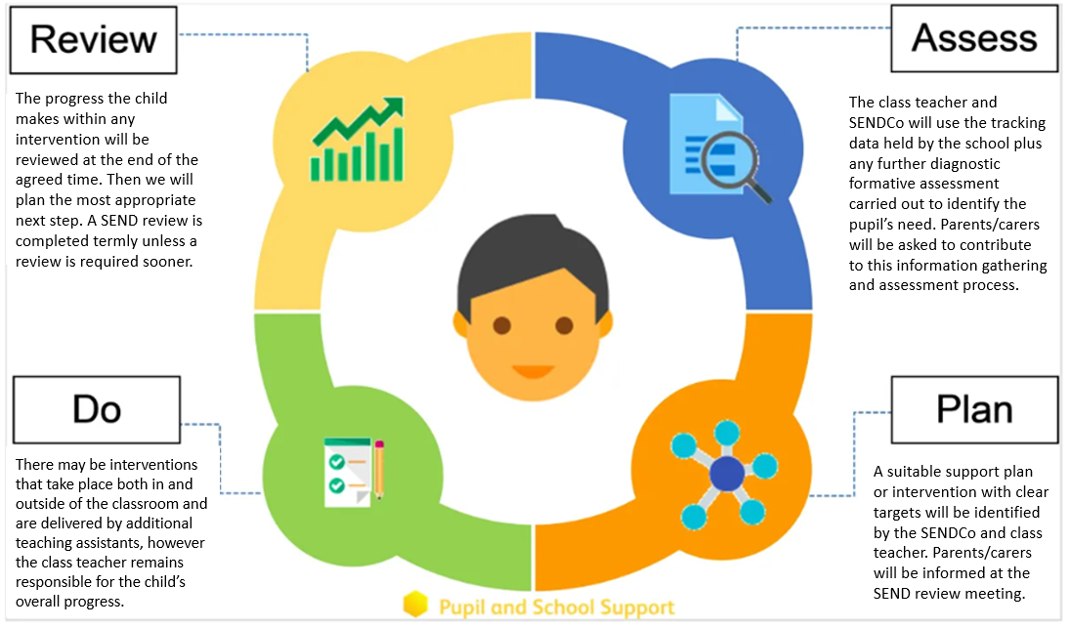

Some pupils may need increased levels of provision and support. The class teacher remains responsible for working with, and devising programmes of work for children with special needs. At Milby Primary School, we follow The Code of Practice and this advocates a graduated response to meeting pupils’ needs. When they are identified as having SEND, the school will intervene through a three tiered response as described below:

Tier 1 – Universal:
Quality first teaching that includes differentiation where appropriate.

Tier 2 – Targeted school support:
Tier 2 is characterised by interventions that are different from or additional to the normal differentiated curriculum.

Tier 3 – High needs:
Tier 3 is characterised by a sustained level of support and, where appropriate, the involvement of external services. Placement of a pupil at this level will be made by the SENDCo after full consultation with parents and class teacher at a target setting review. External support services will advise on new targets and provide specialist inputs to the support process. Parental consent will be sought for any additional information required. The resulting targets will incorporate specialist strategies. These may be implemented by the class teacher but could also involve other adults.

Education, Health and Care Plan
When a child has an individualised programme of SEN support and intervention but remains a significant cause for concern, the school will work closely with parents and external agencies to decide whether a request for Statutory Assessment for an EHC Plan from the LEA needs to be made. Children with EHCPs will have annual reviews of their plan, which will involve the SENDCo, school staff, parents/carers and any other professionals actively involved in the pupil’s provision.

Extra-curricular activities
At Milby Primary School, all of our children have equal access to after school clubs which develop engagement with the wider curriculum. Children with SEND are prioritised to ensure that they have access to a minimum of one club per term, with 1:1 adult support in place if required. Class trips are an important part of our curriculum and we aim for all children to benefit from them. No child is excluded from a trip because of SEN, disability or medical needs. Where necessary, we make accommodations and/or adaptations to meet the physical and learning needs of our children.

Resources
Up to date and stimulating resources need to be available to motivate children and address a variety of learning needs. Resources are readily available throughout the school. Children can also have access to a quiet room which is welcoming and user friendly. Resources include ICT software, which may help with communication and presentation of work, as well as providing equality of opportunity to the curriculum.

Monitoring and evaluation
Children with SEND should not be seen as a fixed group because ‘needs’ may vary over a period of time in response to school policies and teaching. All children identified as having special educational needs are recorded on a SEND register. The register will be amended as necessary, every term by the SENDCo. Parents will always be informed when their child’s SEND status changes.

Training
All staff are encouraged to maintain and improve their knowledge and expertise, in relation to SEND. Requests for training opportunities will be prioritised in discussion between the member of staff concerned, the SENDCo, the Business Manager and Head teacher. The school will run training for staff throughout the year in areas linked to SEND with the expectation of increased staff knowledge and skills based practice. The school subscribes to The National College which gives staff full access to a wide range of online training webinars.

The school’s SENDCo regularly attends SENDCo cluster meetings and termly SENDCo conferences in order to keep up to date with local and national updates in SEND.

Funding
The school receives funding from the LEA for Special Needs, within the general school budget (notional budget), as an amount for children identified with SEN (referred to as devolved funding) and in individual amounts for children with Education, Health and Care Plans, above a specific threshold. The funding is used to provide the support from classroom assistants and/or teaching staff other than the class teacher, to provide materials and resources to use for SEN, to provide cover to enable review meetings to take place and to provide administrative salary costs. Funds received for a child with an EHCP will be allocated to provision for that child, within the terms of their plan, although where provision for a number of children can be usefully combined, this will happen, in accordance with LEA advice.

Roles and responsibilities
Provision for pupils with special educational needs is a matter for the school as a whole. All members of the school community (teaching and non-teaching staff, parents and carers, pupils and governors) work towards the school aims by:

- Helping with the development of this policy
- Being fully aware of the school’s procedures for identifying, assessing and making provision for pupils with special educational needs
- Commitment to a partnership approach to provision

The head teacher has responsibility for the day-to-day management of all aspects of the school’s work, including provision for children with SEN. The head teacher keeps the Governing Body fully informed and works closely with the SENDCo.

Dealing with complaints
We endeavour to deliver an individualised program of provision for children within Milby Primary School. However if you were to become unhappy with the SEN provision your child was receiving the first person to speak to would be the school SENDCo, Mrs Witts, who will try to resolve any concerns and work with parents to adapt or change provision given. If this was not resolved satisfactorily the Head teacher, Mr Archer, would then listen to your concerns and work together with the SENDCo to find an amicable resolution.

Reviewing the policy
The SEN policy will be reviewed at least on an annual basis to ensure that all the information included is relevant and up-to-date.

This policy is reviewed on an annual basis.
The date of the next review is: September 2025.

